Day 1 HTML Assignment:

HTML Task to know usage of basic tags:
- Fix the bugs in below snippet:
<html lang="en">
<head>
<title>Document
<body>
guvi
</title>
</head>
<div>
Lorem ipsum dolor sit amet consectetur adipisicing elit.
<div>
<div>
Guvi Geek Network
</div>
</body>
</html>
Solution:
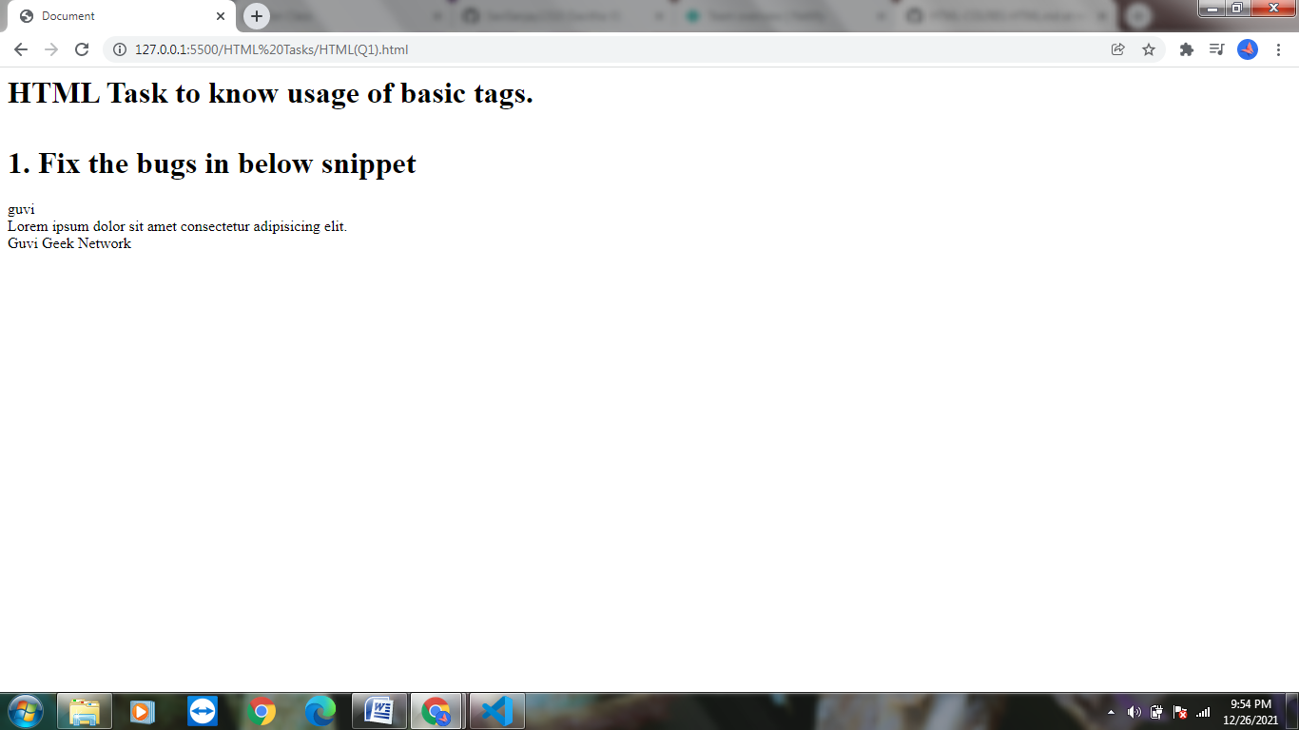

- Try the below one:
<html lang="en">
<head>
<title>Document
<body>
guvi
</head>
<div>
Lorem ipsum dolor sit amet consectetur adipisicing elit.
<div>
<div>
Guvi Geek Network
</div>
</body>
</html>
Solution:
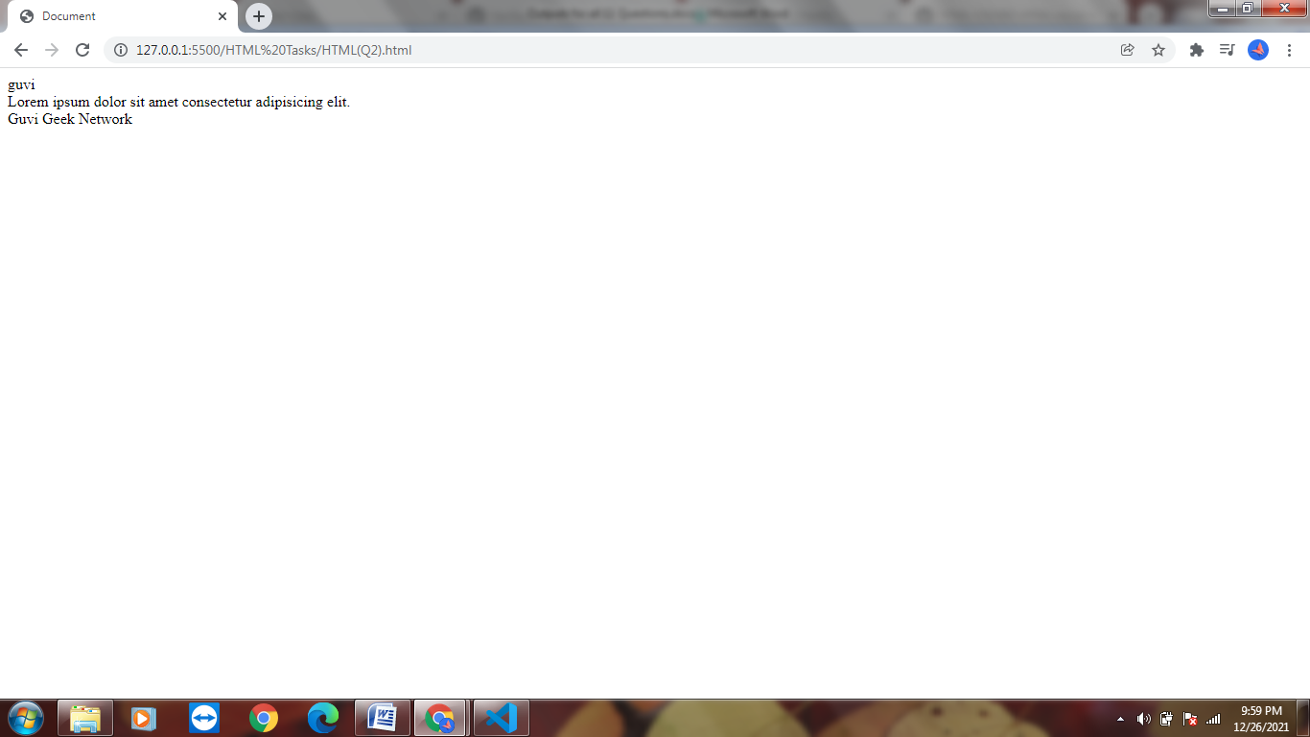

- Design a contact us form with all fields as required.
Solution:
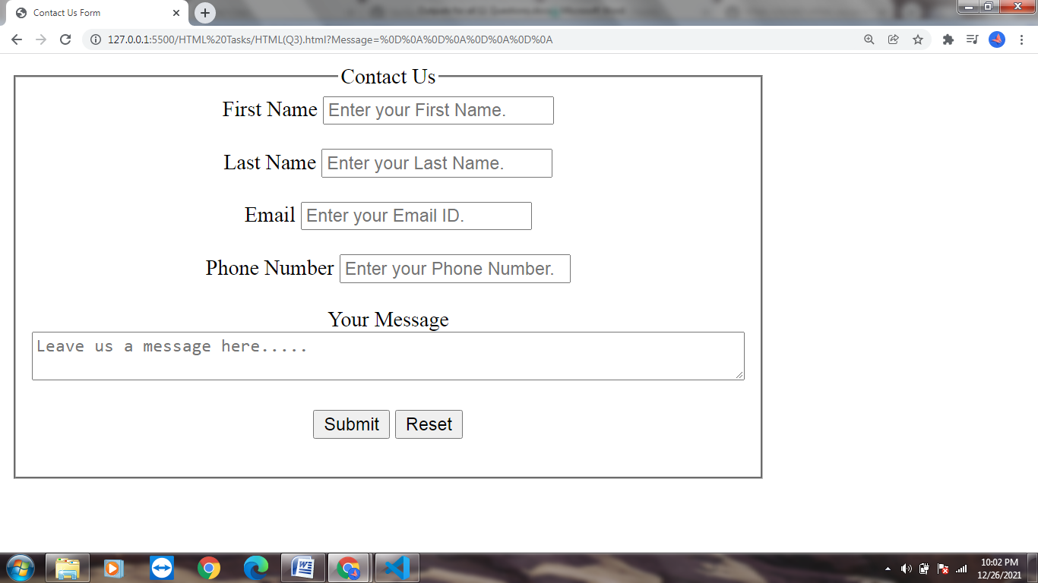

- Use certain HTML elements to display the following in a HTML page.
- Programming Language
  - JavaScript
    - Angular
    - React
    - Vue.js
  - Python
    - Django Framework
    - Flask Framework
  - Java
    - Spring
    - Maven
    - Hibernate
- Database
  - MySQL
  - MongoDB
  - Cansandra
Solution:
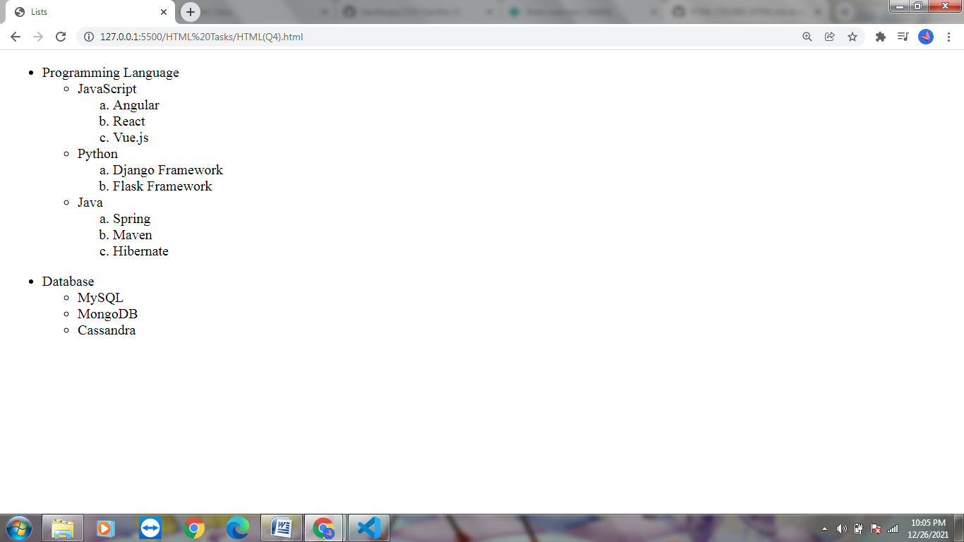

- Create an element that helps you to open the https://google.com in separate new tab.
Solution:
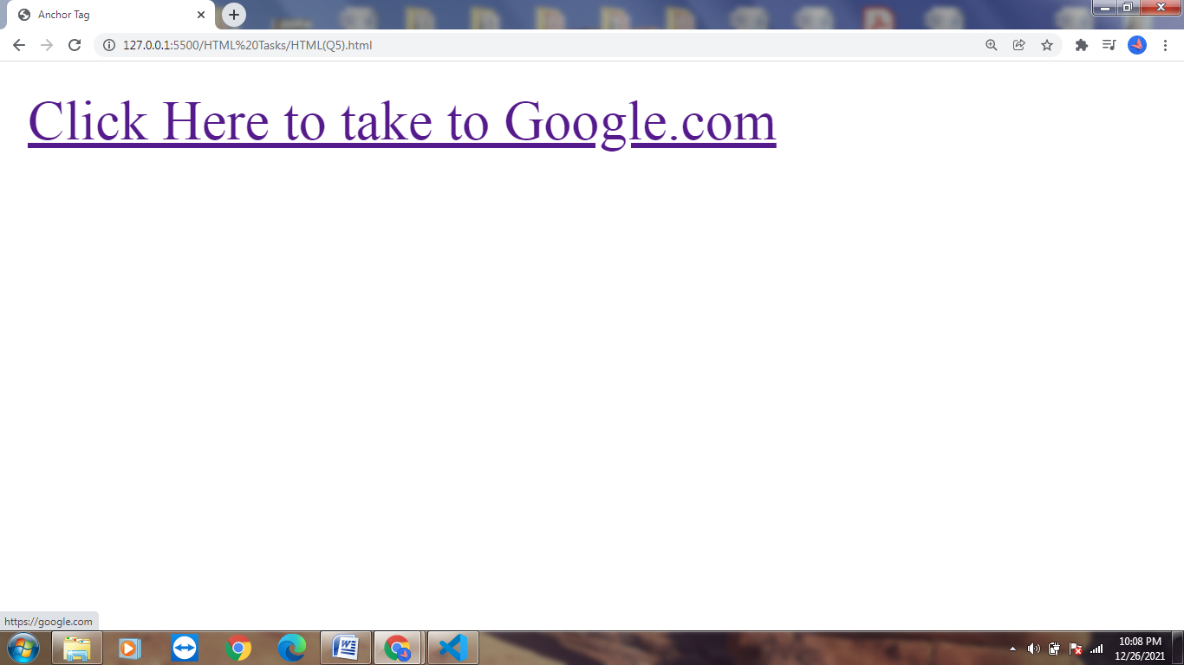
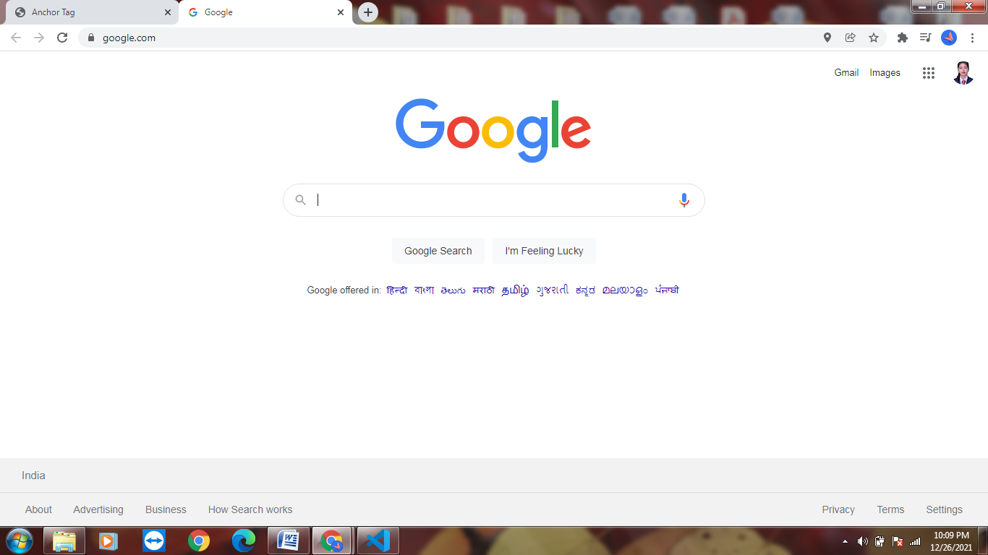
- In the form, add two radio buttons with grouping them for employee type(Salaried and own business).
Solution:
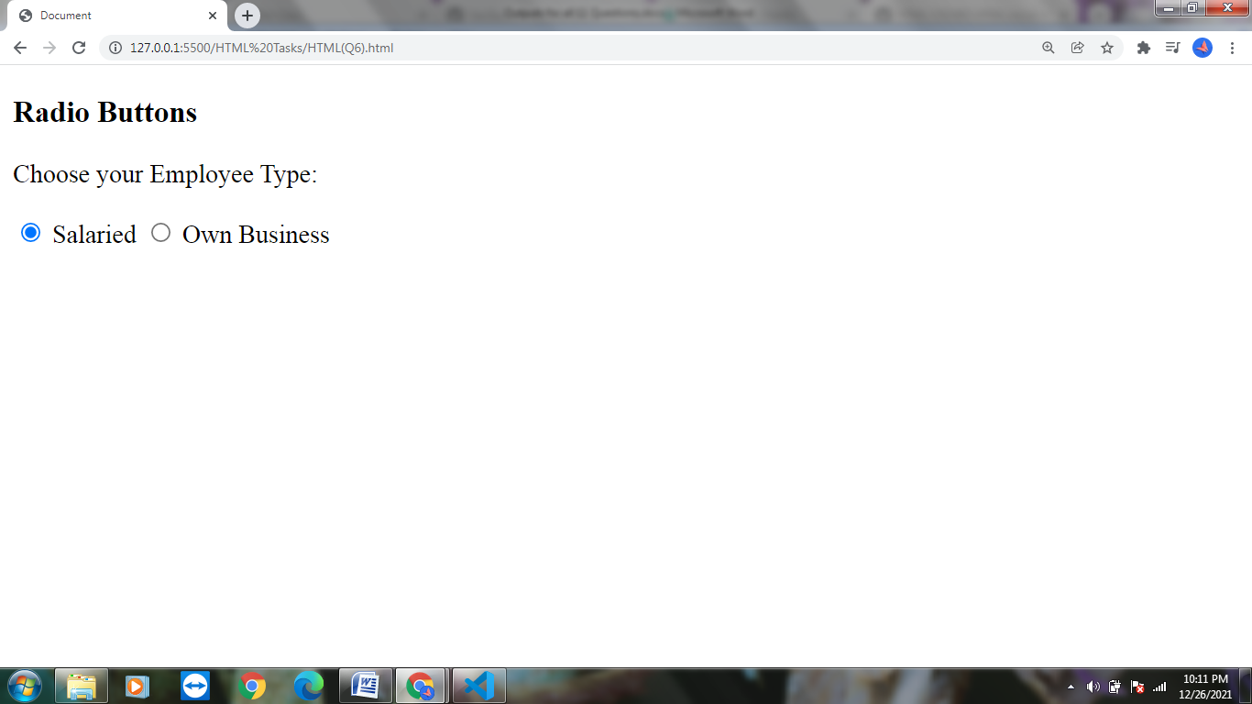

- Design form shown in the link (http://evccit.info/cit040/formguide/card_0.png):
Solution:
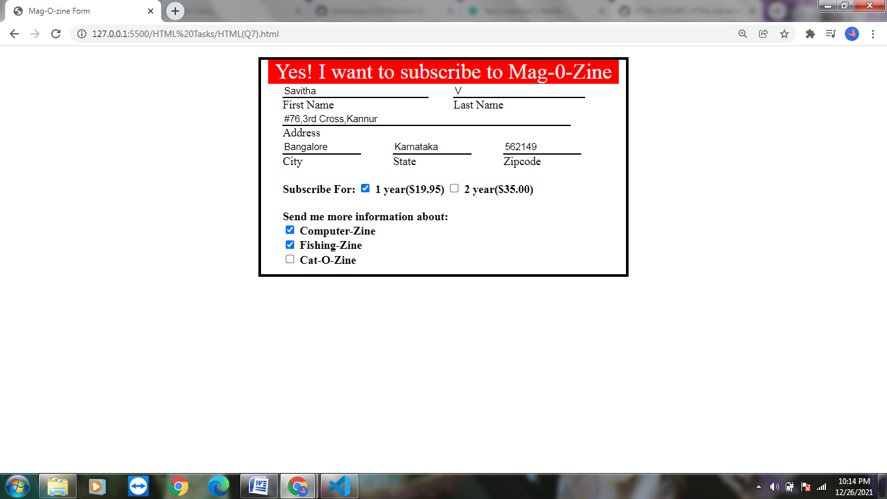

- Use the table tag to design given image Click here.
Solution:
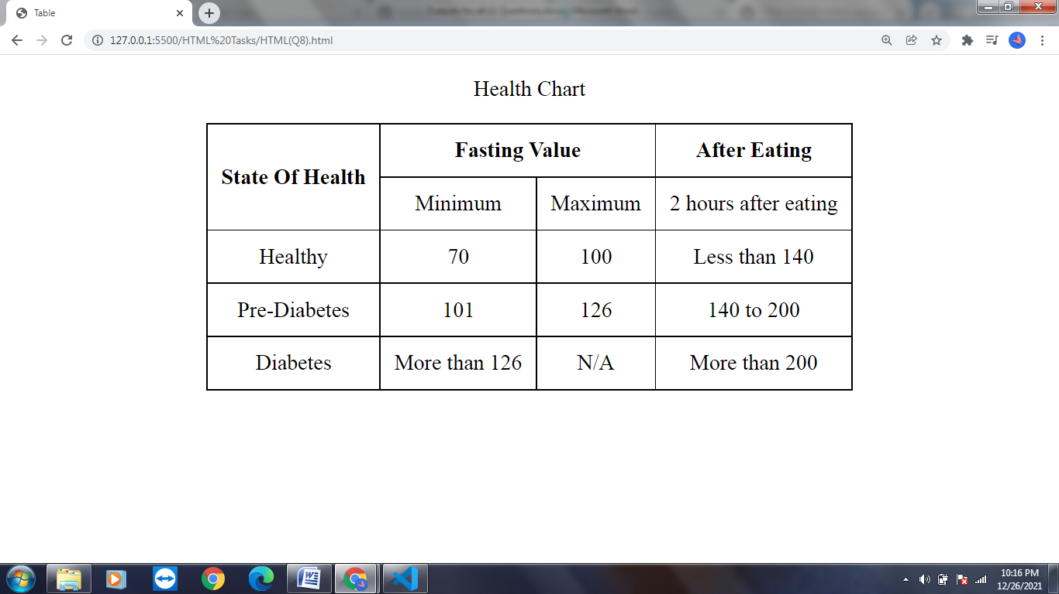

- Write HTML input tags snippet to show default values for all Form elements.
Solution:
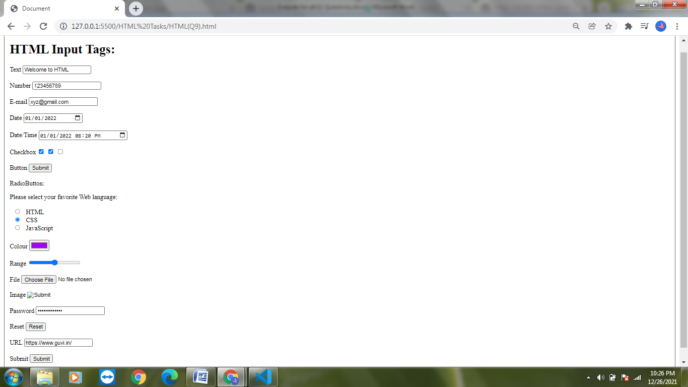

- In your, HTML page add the below line and Highlight it without using any CSS.
- "HTML & CSS is awesome"
Solution:
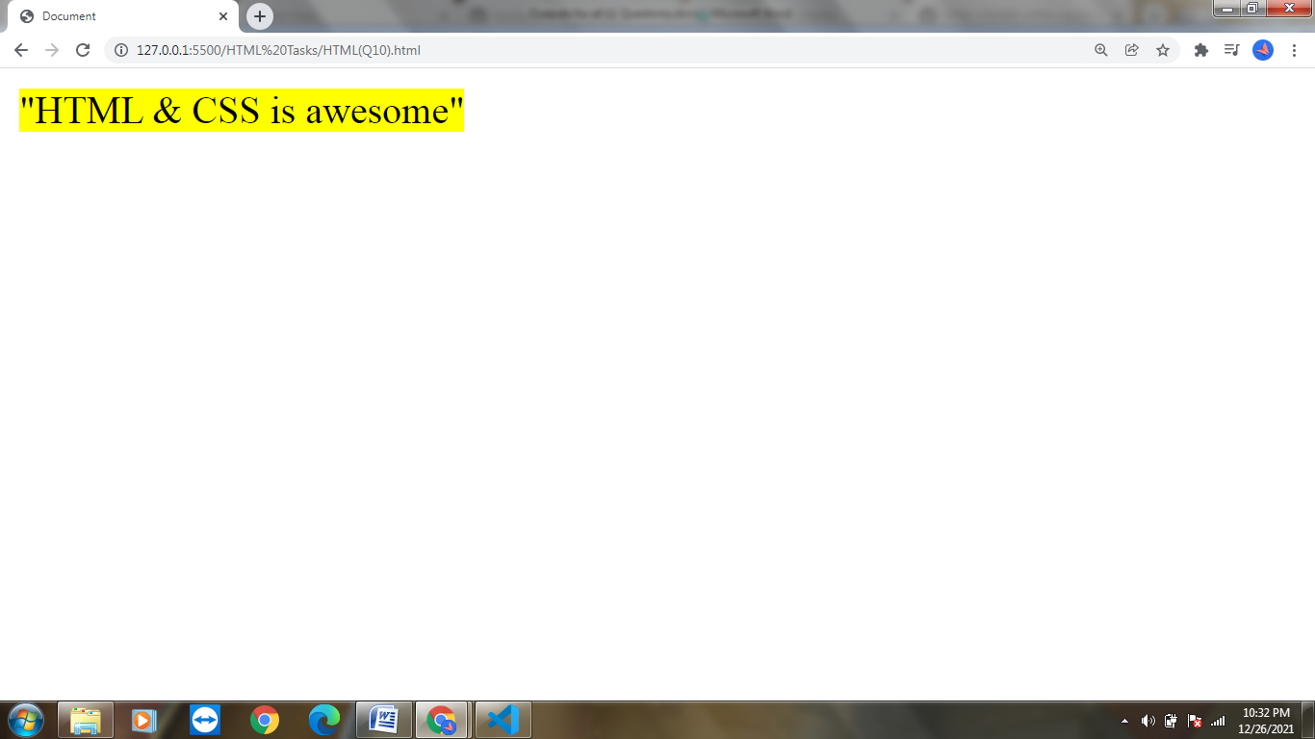

- Create an HTML page, which should contain all types of input elements.
Solution:
